

SMA
USER GUIDE
Version 2.1

1 SMA Process Ownership 1
2 SMA – Service Management Administration Procedures 2
3 Change Control Procedures –User Group 3
3.1 Role of the User Group 3
3.2 Change Process 3
4 Customer Management – Customer Service Manager/Specialist 4
4.1 Create a Customer 4
4.2 Terminate a Customer 6
4.3 Address Maintenance 6
4.3.1 Create a Customer Address 7
4.3.2 Change a Customer Address 7
4.3.3 Delete a Customer Address 7
4.4 Contact Information 7
4.4.1 Adding/Changing/Deleting Customer Contact Information 8
4.4.2 Contact Role Definition 8
4.4.3 How Remedy Uses Contact Information 9
4.4.3.1 Phone Contact 9
4.4.3.2 E-Mail Contact 9
4.4.3.3 Change Control 9
4.4.3.4 Summary 9
4.5 TAC Specific and Industry Information 10
4.6 Contract Information 10
4.7 Activity 11
4.8 Reviews 11
4.9 Tracking 12
4.10 Comments 12
5 Customer Services 13
5.1 Adding a New Customer Service 13
5.1.1 Adding a New Customer Service Manually 15
5.2 Changing a Customer Service 17
5.2.1 Changing a Customer Service Type (Upgrade/Downgrade the service) 17
5.2.2 Moving the location of a Customer Service 17
5.3 Email Setup 17
5.4 Facilities 18
5.4.1 Detailed Circuit Information 19
5.4.2 Network Connections 25
5.4.3 List of Circuits 27
5.4.4 Outstanding Network Connections 28
6 Managed Objects – Design Engineers 29
6.1 Create a Managed Object 30
6.2 Create a Router Managed Object 31
6.3 Adding an Edge Device Managed Object 32
6.4 Changing Managed Objects 33
6.4.1 Changing the Location of the Managed Object - ?? 33
6.4.2 Moving the Managed Object to another Customer Service 34
6.5 Inactivating Managed Objects 34
7 ATM PVC Management 35
8 Making a Customer Service Operational - OSC 38
8.1 Attaching Network Elements to the Customer Service (Correlation Management) 38
8.2 Activating/Terminating the Customer Service 39

Revision History

Date | Version | Contributor | Comments
1998-06-22 | 1.0 |  | Initial Document
2000/02/28 | 2.0 | Bruce Adlington | Revised to reflect system version 4.6.1  (This document is still under construction)
2000-03-27 | 2.1 | Bruce Adlington | Updated section 6 – Managed Objects

SMA – Service Management Administration Procedures

SMA Process Ownership

Error! Not a valid link.

SMA – Service Management Administration Procedures

Maintenance Matrix

The following maintenance matrix lists the SMA functions along the rows of the matrix and the business area groups along the columns. For each function, the matrix depicts the level of authorization and maintenance responsibility each business area group has.

C – Authority to Create a new record.
R – Authority to Review the information.
U – Authority to Update the information.
T – Authority to Terminate an existing record.

SMA Functions | Marketing | Implementation Manager | MAS Design Engineers | Internetworking & ATM Design  Engineers | OSC | Customer Service | Billing  Specialist
Service Definition | CRUT | R | R | R | CRUT* | R | R
Staff Management | R | R | R | R | R | R | R
Usage Calculation | CRUT | R | R | R | R | R | R
Schedule Definition | CRUT | R | R | R | R | R | R
Holiday Definition | CRUT | R | R | R | R | R | R
SLA Definition | CRUT | R | R | R | R | R | R
Customer Management:
Customer | R | CRU | R | R | R | CRUT | R
Primary Address Information | R | R | R | R | R | CRU | R
Address Maintenance | R | R | R | R | R | CRUT | R
Contact Information | R | CRU | CRU | CRU | CRU | CRU | R
TAC Specific and Industry Information | R | R | R | R | R | CRU | R
Customer Comments | R | CRU | CRU | CRU | CRU | CRU | R
Customer Service Management:
Customer Service | R | CRUT | R | R | R | R | R
Facilities | R | CRUT | R | R | R | R | R
Managed Objects (Network Elements) | R | R | CRUT | CRUT | CRUT | R | R
ATM Circuits (PVCs) | R | R | R | R | CRUT | R | R
Correlation Management | R | R | CRUT | R | CRUT | R | R

* Internal Services only

Customer Management – Customer Service Manager/Specialist

Primary: Customer Service Managers/Customer Service Specialists

Super User: ?

Note: Customer, address, and contact information is captured in SRT/DOCS. Therefore, it should not be necessary to add data using SMA. SMA can be used to maintain the data.

Create a Customer

Go to the SMA Main Window – Service Management Administration System

Click on Customer Management

The following window will display:

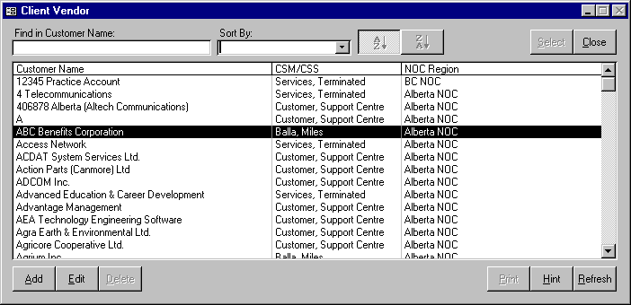

When you first enter this window all existing customers are displayed. You can narrow the list by typing the full or partial customer name in the Find Client Vendor Name field.

NOTE: IN ORDER TO ELIMINATE DUPLICATE ENTRY, TRY SEARCHING ON VARIATIONS OF THE CUSTOMER NAME TO ENSURE IT DOES NOT ALREADY EXIST IN THE DATABASE WITH A DIFFERENT (OR INCORRECT) SPELLING.

If the customer exists in the database it will appear in the search list. To validate or change customer information:

Select the customer by clicking on it, then click on the Edit button.

If the customer does not exist then you must add it to the database.

Click the ‘Add’ button.

The following window will be displayed:

The ‘Client Name’ field should contain the legal name of the company. Take great care to ensure the company name is entered as correctly. (no extra spaces, periods, correct spelling etc.)
The client name is used on reports and correspondence to the client and therefore it is very important that is as accurate as possible.

The Client Short Name is used as a short reference to the legal Client Name. For example, Client Name: TELUS Advanced Communications, Client Short Name: TAC. Once the short name is defined, it is used as a component of the service name, and is used to access HealthNet and CURE reports. The short name can be a maximum of 5 characters.

Select the customer by double clicking, or selecting and then hitting on the Edit button. You will be taken to a screen with the following series of folders or tabs:

Address Maintenance – Maintenance of all addresses for the customer (service location addresses, head office address, billing address etc.) One of the addresses must be a primary business address.
Contact Information – Maintenance of information on people who should be contacted for different reasons concerning TAC.

TAC Specific and Industry Information – Maintenance of information about the TAC people who are responsible for the customer.

Contract Information – Specific information regarding the contract.

Activity – A log of key communications with the customer.

Reviews – A log of formal customer service reviews.

Tracking – This is a list of all of the customer’s services (design, operational, terminated). There is also a section for revenue information.

Comments – Freeform space for customer information.

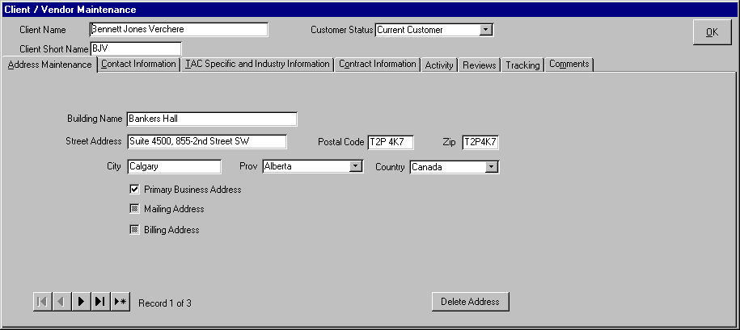

Terminate a Customer

The Delete button has been disabled. (At one time, it was available for SuperUsers)

Address Maintenance

Click the Address Maintenance Tab

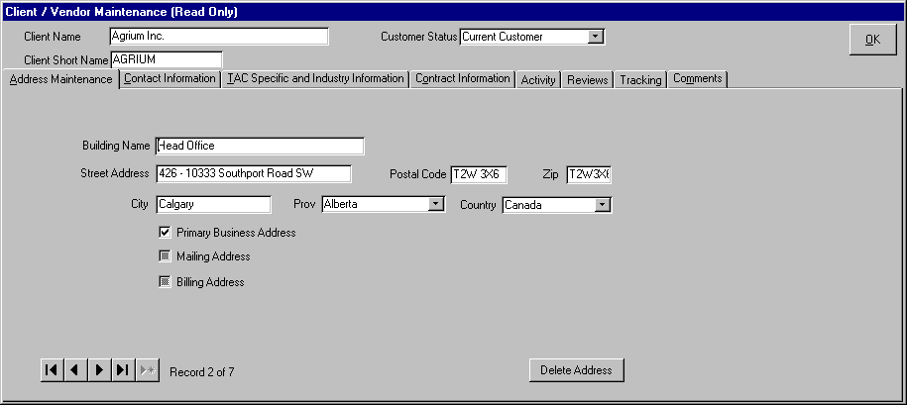

Create a Customer Address

There must be an address for every service location. This tab can be used to record multiple addresses. The Building Name is not mandatory, but if it is known, it should be the official name of the building.

Use the check boxes to define the address (more that one box can be checked). It is mandatory to define a Primary Business address.

Change a Customer Address

An address should be changed only if the information has been entered incorrectly.

If the customer is moving addresses, then a new address should be created.

Delete a Customer Address

The system will not allow delete of an address that is being used as a billing address or as a service location.

If an address is not being used as a billing address or service location address, it can be deleted from the database by clicking the ‘Delete Address’ button.

Contact Information

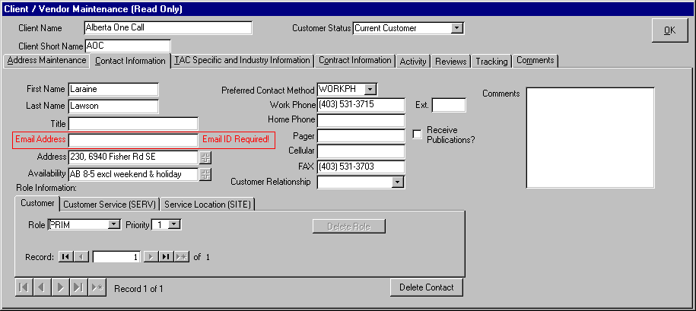

Adding/Changing/Deleting Customer Contact Information

Customer Service is has the overall responsibility for inserting/updating/deleting customer contact information. Implementation Managers will also make changes to this tab in order to keep customer contact information accurate and current.

Any other group that receives changes to this information via the customer will notify Customer Service by e-mail. The Customer Service Manager responsible for the customer can be found in Customer Management: TAC Specific and Industry Information: Customer Care Specialist. If the Customer Care Specialist information is missing, send the information to the Super User of Customer Management.

The Receive Publications check box indicates whether or not the customer wants to receive a newsletter. Notes which pertain to the Customer Relationship should be included in the Comments.

Contact Role Definition

Use the pull-down to select and view the roll definitions. Every customer must have a PRIM 1 contact – This is the primary technical contact for the customer and is the fallback contact used by the Remedy system for Trouble Ticketing. . It is recommended that PRIM 1 and PRIM 2 always be assigned. Refer to the next paragraph for more information on roles and priority.

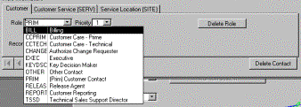

How Remedy Uses Contact Information

Phone Contact
There are often many contacts for each customer, and each contact can have one or multiple roles assigned to them. The important thing to remember is that these contacts in the database are used by Remedy T2 and C2, and by Operations to provide contact information when alarms are detected on TAC equipment located at their sites. These automatic alarms create Remedy T2 tickets which will have customer contact information attached.

By default, Remedy will attach the SITE1 contact to any automatic (Spectrum created) trouble ticket on any specific element. This will only happen if a customer contact is defined as a SITE contact and the specific element is linked to that site location and customer in the SMA Managed Objects. Otherwise, if no site contact is available, the PRIM1 will be attached. If neither a SITE1 nor PRIM1 is defined for the customer, the contact information in the ticket will be blank. However, all contacts can be queried via the pull down menu on the ticket. The SERV1 contact is only used for E-Mail notification.

It is valuable to have site contacts when the OSC requires confirmation of power and physical connectivity, as in most cases, the tickets are created by the systems and not called in by the customer. In cases where we have customers that want a single point of contact from a networking perspective, then SITE contacts should not be defined, and the PRIME1 should be the customer helpdesk or main technical contact (7x24).

E-Mail Contact
Contact information is also used by Operations when sending email notification to customers for upcoming maintenance window activity that will affect their service, and for customer notifications and updates when a global outage occurs that affects multiple customers and services.

From both C2 and T2, an email distribution can be created for the customers that are linked to the service tags on any change ticket or trouble ticket. As a result of service correlation, any element that has a change or trouble ticket can have an email distribution list created for quick and easy notification. Obviously, this is only possible if the customer contacts are defined properly in the ESD and their correct email addresses are also entered.

Email notification (for all customer services) will be sent to the following customer roles:
- PRIM1 (Helpdesk- email should be the helpdesk email or an email that distributes to multiple contacts within the organization).
- PRIM2 (Manager or Lead Communication Analyst)
- SERV1 (Technical contact for a specific service i.e. Web Hosting).

The only time a SERV1 contact needs to be defined is if a specific customer has multiple services, and for some of these services they would like a different person contacted. We find this to be the case when a customer has purchased both Internetworking and Internet Hosting services. Often the customer’s organization is such that different people are responsible for the LAN/WAN and the Hosting Services.

Change Control
Another Role is the CHANGE role. This is used by operations to confirm that a specific customer contact has the authority to request changes to an existing service. The customer change process allows a customer to request a change by emailing the OSC with the details. This email must be received from an authorized change requestor for that customer. So, if a customer is going to be requesting changes, the contacts that are authorized must have CHANGE roles assigned in the ESD.

Summary
Customer contact information is defined and maintained by Customer Service Management. It is very important that they ensure that customer contacts are correct and have the proper roles assigned to them. Service Management should verify that the contact information is correct when they do their quarterly customer service reviews.

TAC Specific and Industry Information

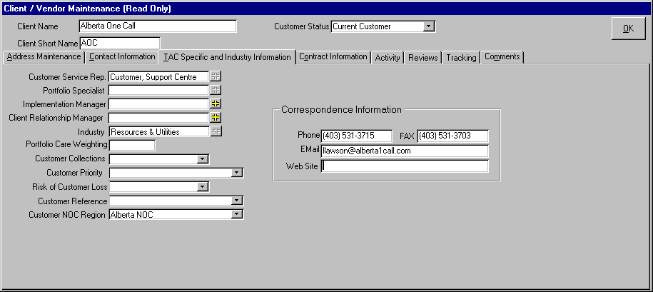

Customer Service Rep – CSM (Customer Service Manager) or CSS (Customer Service Specialist)

Portfolio Specialist – No longer used.

Implementation Manager – The Implementation Manager who is responsible for this customer.

Client Relationship Manager – Sales Representative.

Industry – Select the customer’s industry from the dropdown list.

Portfolio Care Weighting – Set on a scale of .25 to 3.0, and is a measure of the complexity and support requirements of the account.

Customer Collections – No longer used. Refer to Arbor.

Customer Priority – This is a measure of the customer’s value to TELUS.

Risk of Customer Loss – This is a reflection of the customer’s financial stability.

Customer Reference – Will the customer do a referral for TELUS?

Customer NOC Region –

Correspondence Information – Contact information for the CSM/CSS.

Contract Information

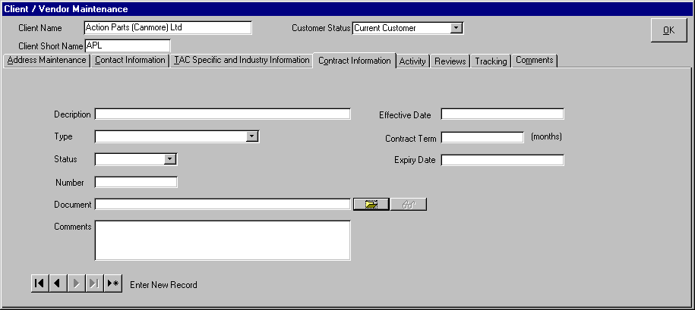

This is used exclusively by Customer Service for the optional manual input of contract information.

Activity
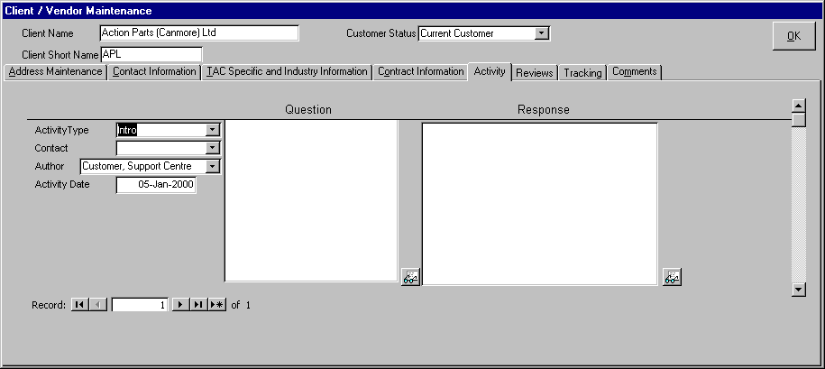
This tab is used to track key discussions with the client. Reports can be run on this information.

Reviews

This is for Customer Services use only. It is used for tracking formal service reviews (post service delivery/ongoing OSC/service review).

Tracking

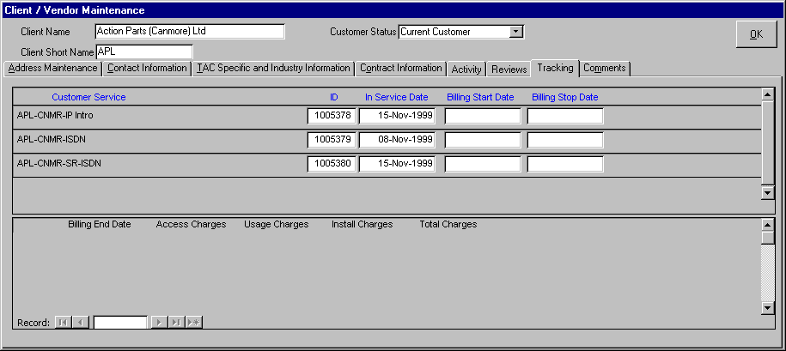
This is a digest of all of the customer’s services. The revenue section is optional manual input.

Comments

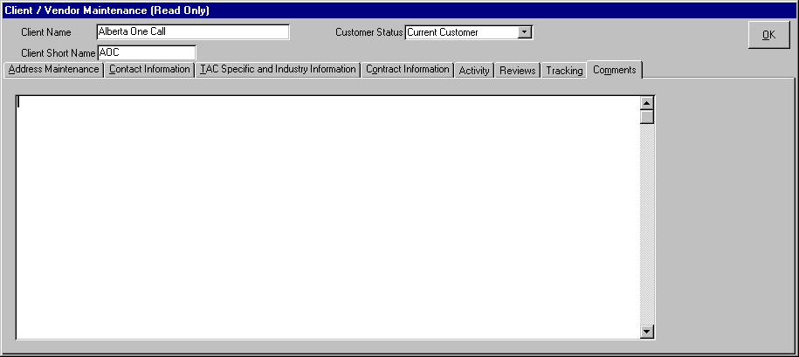

The comment section is a freeform space to enter any information that is not entered elsewhere in the system. The comment can hold a maximum of 2000 characters.

Customer Services

Super User: Lee Ettinger

GOTO Customer Service Management Window

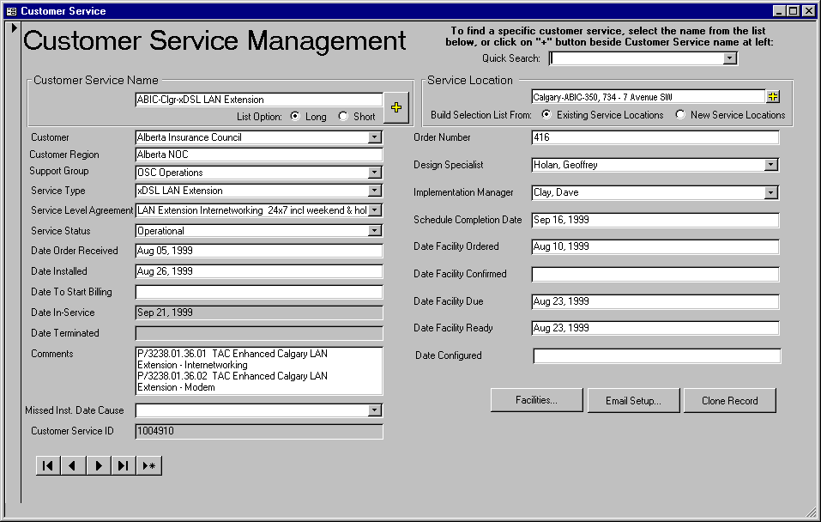

Adding a New Customer Service

The Customer Service Name is a unique reference to this customer service. The standard naming convention is as follows:
Customer Short Name ‘-‘ Abbreviated City Name ‘-‘ Unique Identifier (i.e. building name, street address, floor number, etc.) ‘-‘ Service Type.
Example: ACB-EDTN-Cross Cancer Institute-Ethernet Native.
The  sign will list existing customer services. The short list displays Customer Service/Customer Service ID. The long list adds Client, Client Short Name and Service Location.
If the service is Ethernet Native, Fast Ethernet Native, LAN IC, or LAN Extension, then a second service has to be built for the Standard Reporting. The Service Name will be the same as the name given to the service, with ‘SR’ added in front of the service type.
Example: ACB-EDTN-Cross Cancer Institute-SR-Ethernet Native.
The DOCS system can build a customer service in SMA for you. Find the order in DOCS, and select the Contacts and Provisioning tab. Select the correct service, and hit the SMA button. Note: Only those individuals who are responsible for creating services in SMA are given security access to use this DOCS feature. Also, the service must be in ECOPS, and assigned an Overall Prime before SMA can be updated.
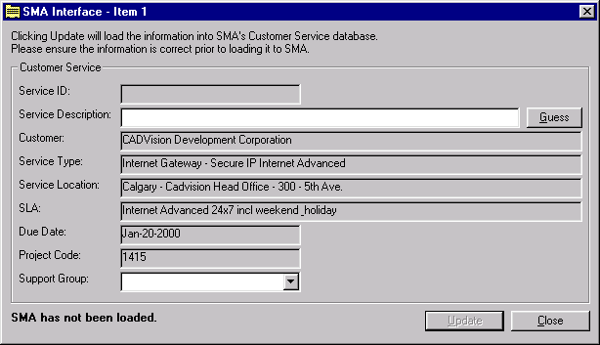
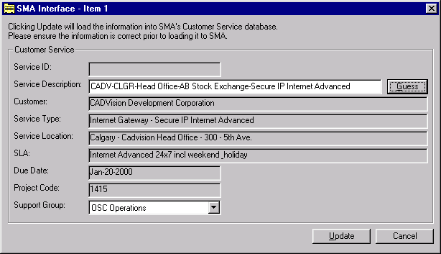
The screen shot above is the SMA screen in DOCS. Press the Guess button to have DOCS build the Service Name, and correct it manually if required. Select the Support Group, and press the Update button to load the service into SMA. Note: Project Code is the DOCS order number.
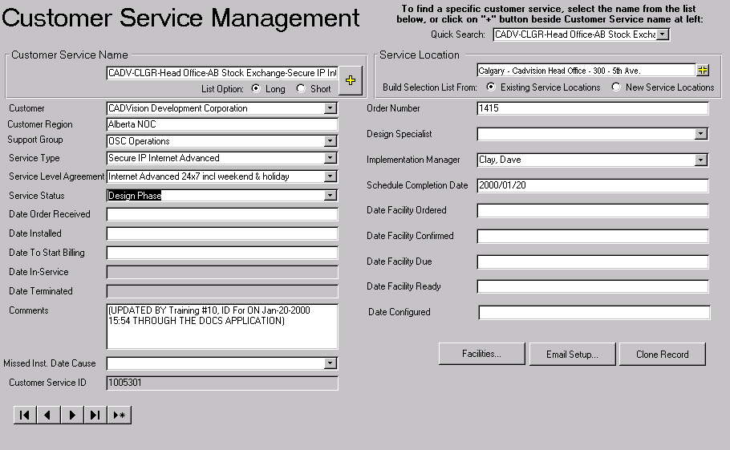
The above screen is the result of creating the Service from DOCS. Note that the Comments were automatically filled out to indicate that the service was created through DOCS.

Adding a New Customer Service Manually

By Cloning
Use the Clone Record button to use the current record as a template.
From Scratch
Select the Customer from the dropdown selection list. If the customer does not exist in the list, see Create a Customer process.

Customer Region – The Customer NOC Region as defined in Customer Management.

Support Group – Defines the Operations support group by Region.

Select the Service Type from the dropdown selection list. If the service type does not exist in the list, see Create a Service Type process.

Select the Service Level Agreement from the dropdown selection list. If the service level agreement does not exist in the list, see Create a Service Level Agreement process.

There are 3 valid Service Status Codes for a customer service.
DESIGN – When adding a new customer service, the status will default to design. A design status indicates that the customer service is not being monitored or supported by the Operations Service Centre (OSC) nor is the customer being invoiced for the service.
OPERATIONAL – The Operations Service Centre (OSC) is responsible for changing the status of a customer service to operational. An operational status indicates that the customer is free to use the service, OSC is fully monitoring and supporting the customer service and Customer Care is invoicing the customer for the service.
TERMINATED – The Operations Service Centre (OSC) is responsible for changing the status of a customer service to Terminated. A terminated status indicates that the customer can no longer access and use the service, OSC is no longer monitoring and supporting the customer service and Customer Care is no longer billing the customer for that service.

Date Order Received – Manually populated, based on DOCS

Date Installed – Manually populated when the installer phones in to confirm the installation in complete.

Date to Start Billing – This is the same as the Date In-Service.

Date In-Service – This is automatically populated when the service is made Operational by OSC.

Date Terminated – This is automatically populated when the service is changed from Operational to Terminated by OSC.

Comments – If the service was created in DOCS, then a comment is added automatically. Otherwise, it is manual input. SAP numbers can be placed here.

Missed Inst. Date Cause – Manual input, selected from a drop down list.

Customer Service ID – This is a unique system generated number.

Select the Service Location from the dropdown selection list. If the service location does not exist in the list, see Create a Customer Address process.

The Order Number is the DOCS order number.

Select the Design Specialist from the dropdown list. This list is populated with information from the Staff system. If the Design Specialist does not appear in the list, contact Human Resources. THIS NAME WILL BE USED AS THE E-MAIL RECIPIENT WHEN GENERATING THE DESIGNER NOTIFICATION. See Notifying the Design Special and Installation process.

Select the Implementation Manager from the dropdown list. This list is populated with information from the Staff system. If the Implementation Manger name does not appear in the list, contact Human Resources.

Scheduled Completion Date is the date the customer service is expected to be operational.

The following information is used for Facility Order Tracking and Monitoring. Facility tracking is done in ECOPS, so it is not necessary to enter the following dates.
Date Facility Ordered – Enter the date the facility was ordered.
Date Facility Confirmed – Enter the date the facility provider confirmed the facility order.
Date Facility Due – Enter the date the facility should be operational.
Date Facility Ready – Enter the date that the facility was actually ready.
Date Configured -

Changing a Customer Service

Changing a Customer Service Type (Upgrade/Downgrade the service)

Terminate the old service and add a new customer service. See Create Customer Service process.

DO NOT change the service type on a Customer Service that is operational. This will cause problems for Billing. If for some reason the service type of a customer service must be changed, ensure Customer Care – Billing Specialists are informed.
This process creates an audit trail.

Moving the location of a Customer Service
- Select the correct address, or create a new one if it does not exist.
- Select or build a service location name.
- When the service is physically moved, change the service location name on the Detailed Circuit Info screen.
- Add a comment.

Email Setup
The dialog displayed below allows users to configure automatic email distribution when a service status changes form one status to another (service status transition eg. Design to Testing). After entering a service status transition, click the associated check box of the individuals that are should be notified if the transition occurs. When an email message is sent the email address of the managers and specialist are retrieved from the staff table. If the email address is invalid the Microsoft Exchange resolve dialog will appear. If the user selects to cancel the resolution dialog no email message will be sent.

Facilities

The facilities button will access the Circuit/Network Connections screen. Here, circuits and network connections can be viewed or built. A facility is a circuit that is ordered from outside of TAC. The facility types are: Fibre, Frame Relay, ISDN, ADSL, T1 or copper.

The Circuit / Network Connections screen is broken down into four sections (tabs), Detailed Circuit Information, Network Connections, List of Circuits, and Outstanding Network Connections. The main component of this screen is the Detailed Circuit Information where circuit data can be viewed, updated and entered into the database. The data for all the other sections is derived from the Detail Circuit Information. The Outstanding N/C (Network Connections) is used to assist in the process of updating network connection information. Because the network connections are entered into the system automatically from OSI (auto-discovery), some of the data is incorrect and must be changed. The Network Connections and List of Circuits sections are simply used to display circuits by customer or customer service. If a new circuit or network connection needs to be added to the database, the addition can only be done through the Detailed Circuit Information section.

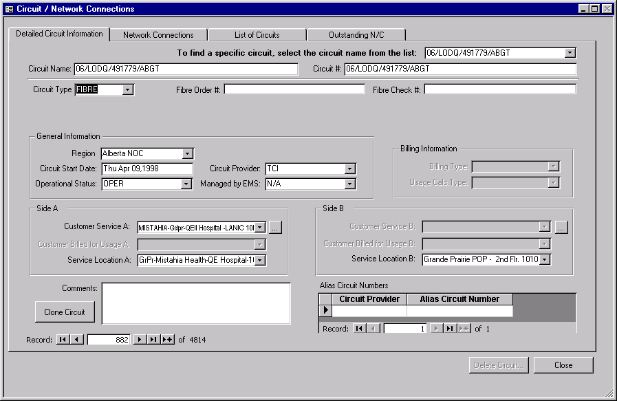
Physical circuit.

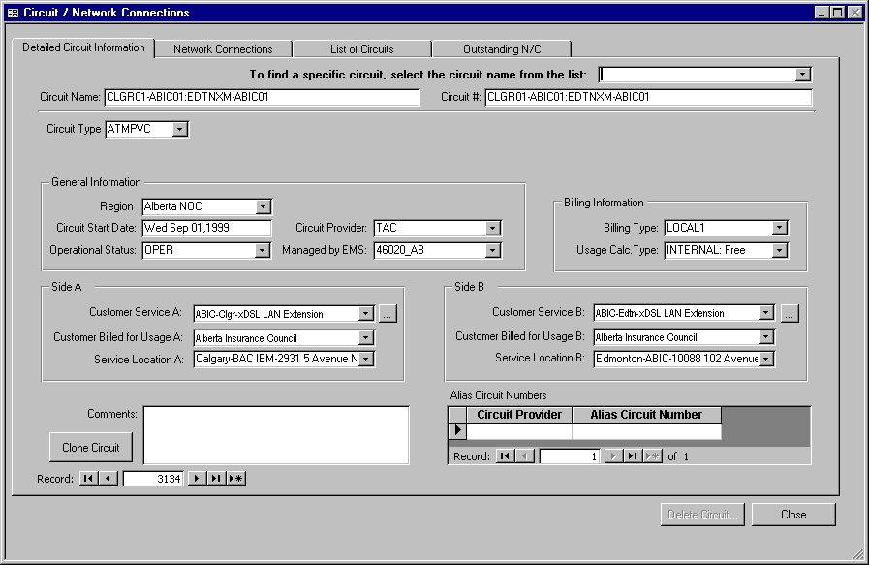
Logical circuit.

Detailed Circuit Information

A circuit is a “physical” path on the network on which electronic data can travel from one point to another. While a network connection is a “logical” connection between two service locations, it is “physically” built as one or more circuits. It is crucial to accurately measure/monitor traffic on every circuit because this is the source of all customer usage calculations required for billing. Currently the following circuits types have been identified: ATM, Fibre, Frame Relay, xDSL and ISDN.

Circuit # / Circuit Name

The Circuit Name will default to the Circuit #, however, it can be overwritten.

The following are examples of what the different circuit numbers can look like:

ATM - PVC (see PVC Names below)
Fibre - 06/TYDT/274338//ABGT
Frame Relay - 05/QHDQ/102250/003
ISDN - 403-207-8826 / 403-207-8827 (ISDN looks like a phone number)
xDSL - 06/ARDR/315992//ABGT

PVC Names
(Logical circuits are added by the OSC)

The Circuit Number is a unique number used by EMS (Element Management Software).
Name Standard
PVC names will generally include the names of the two endpoints separated by a colon. The path name can be a maximum of 33 characters.

endpoint_a:endpoint_z

Example:

CLGRABEZ-TCPL01:CLGRABEZRR01

Paths to Cisco Catalysts in Central Offices
To clarify path names that terminate on Cisco Catalysts that are in a central office, the following extension to the core equipment name will be used to allow multiple paths to be created to a single Catalyst.

Place | Province/State | Building | Equipment Identifier |  | VLAN #  (optional)
(1 - 4) | (5 - 6) | (7 – 8) | (9 - 12) | 13 | (14-16)
a a a a | a a | (a) (a) or (n) (n) | (x) (x) (n) (n) | - | (n) (n) (n)

Paths for ADSL VPOP
BC Design
Since paths for ADSL VPOP service will not terminate on Telus equipment at the customer end the following standard is proposed for path names:

ISP | Phone Number |  | Catalyst 5505 Equipment Name
(1 - 5) | (6-17) | 18 | (19-30)
a a a a a | 604-987-1232 | : | VANCBC01-(n)(n)(n)

Where (n) (n) (n) = VLAN # on Catalyst

Alberta Design

CLGR46-ADSL-VPOP-926:CADV-118

This name is used to describe the PVC that connects from a specific POP, back to the ISP site via the 100M ISL Trunk. (this PVC has statistics collection enabled)

CLGR46-AGGREG-925:CADV-277-6264

This name is used to the PVC from the DSLAM to the Aggregation VLAN on the Catalyst.

Framewerx Path Names

Prefix | FrameNetNum | Delimiter | Segment | DLCI | Delimiter
aa | (n)(n)(n)(n)(n)(n) | / | (n)(n)(n) | (n)(n)(n) | :

Prefix | FrameNetNum | Delimiter | Segment | DLCI
aa | (n)(n)(n)(n)(n)(n) | / | (n)(n)(n) | (n)(n)(n)

Example:

FR100123/001016:FR100123/002017

Circuit Type
The Circuit Type defines what type of circuit is being used for a particular customer. All circuit types are located in a drop down screen for the user to choose from.

Examples:
ATMPVC
FIBRE
FR (Frame relay)
ISDN
Region
The region which is responsible for the circuit.

Circuit Start Date
The Circuit Start Date specifies the date that the circuit was operational and available for use by the customer. This is a date only field and should be entered as weekday, month day, year.

Example: Thursday, July 3, 1997

Operational Status
The Status helps to define the stage that the circuit is in. The choices are as follows:
- OPER - Operational. This status indicates that the facility or PVC is being used by a Customer Service, but is not being billed.
- OLD - means that the circuit is old and may not be in use.
- UNKNWN - Unknown. This status is used for ATM PVC circuits only, DO NOT USE for facilities. A status of UNKNWN is set when the ATM PVC is auto discovered by the Usage Collection Process
- BILL - means that the circuit is operational and is being billed.
- DEFINE - This is used to indicate that the circuit is being built in SMA.
- N - Not used, should be deleted from list.
- TERM - Terminated. This status indicates that the facility or PVC is no longer in use by a Customer Service.
- Aug 16 - Not used, should be deleted from list.
The status is located in drop down screens for the user’s convenience.

Circuit Provider
The Circuit Provider defines who the circuit belongs to. There is a drop down list of possible circuit providers to chose from.
Examples:
TAC
TCI
BAC
client
Managed by EMS
A circuit can be managed and monitored by different types of software. The Managed by EMS (Element Management Software) defines which type of software is being used for a particular circuit. All software is located in drop down screens for the user’s convenience.

Examples:
HPOpenView
SPECTRUM
46020
Billing Type
The Billing Type describes whether the bill is on a local, regional, or national scale. It helps to define how to calculate the usage and price. All billing types are located in a drop down screen for the user’s convenience.

Example:
LOCAL1
NATIONAL2
REGIONAL3
Billing Information: Billing information is used by the daily usage rollup process. If this information is missing, the usage statistics will not be rolled into the table which is used by the billing process and therefore the customer will not be billed accurately for this circuit.

Billing Type: There are 11 options when choosing the correct billing type.

IX – DO NOT USE this value. It was originally intended to indicate that the PVC logically connected two points in different cities (long distance). It has been replaced with REGIONAL1, REGIONAL2, REGIONAL3, NATIONAL1, NATIONAL2, NATIONAL3.

LOCAL1 – Use when the PVC logically connects two points within the same MAJOR city within Province (i.e. Calgary, Edmonton, Vancouver)

LOCAL2 – Use when the PVC logically connects two points within the same MIDSIZE city within Province (i.e. Grande Prairie, Red Deer, Prince George)

LOCAL3 - Use when the PVC logically connects two points within the same SMALL city or town within Province (i.e. St. Albert, Sherwood Park, Salmon
Arm).

METRO – DO NOT USE this value. It was originally intended to indicate that the PVC logically connected two points within the same city. It has been replaced with LOCAL1, LOCAL2, LOCAL3.

REGIONAL1 – Use when the PVC logically connects two points in two different MAJOR cities (i.e. connection between Calgary and Edmonton).

REGIONAL2 – Use when the PVC logically connects two points in two different cities where one of the cities is a MIDSIZE city and the other is either a MIDSIZE or MAJOR city. (i.e. Red Deer to Calgary, or Grande Prairie to Lethbridge).

REGIONAL3 – Use when the PVC logically connects two points in two different cities where one of the cities is a SMALL city/town and the other is either a SMALL, MIDSIZE or MAJOR city. (i.e. St. Albert to Calgary, or St. Albert to Lethbridge, or St. Albert to Sherwood Park).

NATIONAL1 – Use when the PVC logically connects two points within Canada where one or both points is outside of Alberta.

NATIONAL2 – Use when the PVC logically connects two points within North America where one or both points are outside of Canada.

NATIONAL3 – Use when the PVC logically connects two points in the World where one or both points are outside of North America.

Usage Calc Type: There are 3 options available, these are:

Internal – Choose this value when the PVC is not to be billed to the customer. For example, if you have a PVC which is to be used for stats collection only, set this indicator to ‘Free’.

INET – Choose this value when the PVC connects an internetworking service where both sides of the service are being billed for receipt usage.

LANIC – Choose this value when the service is a LAN Interconnect and only one side of the service is being billed to a customer and the other side connects to a TAC CO or POP.

Side A and Side B information is required for the billing system to function properly.

Customer Service A & Customer Service B
When a new circuit is entered in to the system, Customer Service A is always required. This identifies which customer and for what service the circuit belongs. Customer Service B is only required when a PVC circuit or network connection is entered into the system. When a new customer service is entered into the database through the customer service screen (Refer to section 12 Customer Service Management), information such as customer and service location is also entered. These values are used to automatically populate the billing customers and the service location fields of a circuit.

Billing Customer A & Billing Customer B
These fields are optional depending on the type of circuit. If there are usage charges associated with a circuit such as a PVC circuit then these fields will become enabled and a customer can be selected. If a billing customer is required the default customer will be the same as the customer who owns the service customer.

Service Location A
The Service Location A defines the “from” location. The circuit begins at the A (from) location and connects to the B (to) location. The Service Location defines every aspect of a locations whereabouts for a specific customer. It begins by stating the city that the service location can be found in. The city name should be full-length beginning with a capital letter. Following it is the name of the organization. The client short name comes in place for entering the name of the organization. This should be the same short name as seen on the main Customer Management screen. Last is the street address. A minus sign ( - ) with a space on either side should be placed between each section as a divider.

Example: Calgary - TAC - CO - Suite 200 355 - 4th Ave SW

Service Location B
The Service Location B defines the “to” location. The circuit begins at the A (from) location and connects to the B (to) location. The Service Location defines every aspect of a locations whereabouts for a specific customer. It begins by stating the city that the service location can be found in. The city name should be full length beginning with a capital letter. Following it is the name of the organization. The client short name comes in place for entering the name of the organization. This should be the same short name as seen on the main Customer Management screen. Last is the street address. A minus sign ( - ) with a space on either side should be placed between each section as a divider.

Example: Edmonton - EPSB - One Kingsway Ave

Clone Circuit
This button will create a new circuit which is identical to the circuit displayed, minus the Circuit Name and Circuit #. These fields have to be populated with the new circuit name and number in order to save the circuit.

Comments
The Comment field can be used for any comments or extra information. This field is free writing of up to 2000 characters.

Alias Circuit Numbers: Only complete this information when a circuit used in a Customer Service is provided by a company other than TAC. This field holds information about the circuit that can be used to refer to it in the other company.

Facility Provider – The name of the company providing the circuit.

Alias Circuit Number - The name the circuit is referred to by the provider company.

Network Connections

Customer Service

Service Location A
Network Connection

Service Location B

A network connection defines the physical connection between two service locations. Every customer service is composed of one or many network connections.
For example:
A B C
Edmonton

Calgary
D E F

Internet Access.
There are two ways to define customer services and network connects for this example.
Method #1: Individual Customer Services
This customer has 6 service locations. The customer purchased 6 LAN IC 10M services, one per service location, and one Internet Access service.

Method #1: Grouped Customer Service
This customer has 6 service locations. The customer purchased one LAN IC 10M service. This service is composed of 5 network connections: A-B, B-C, B-E, D-E, E-F. There are 4 local connections and 1 regional connection.

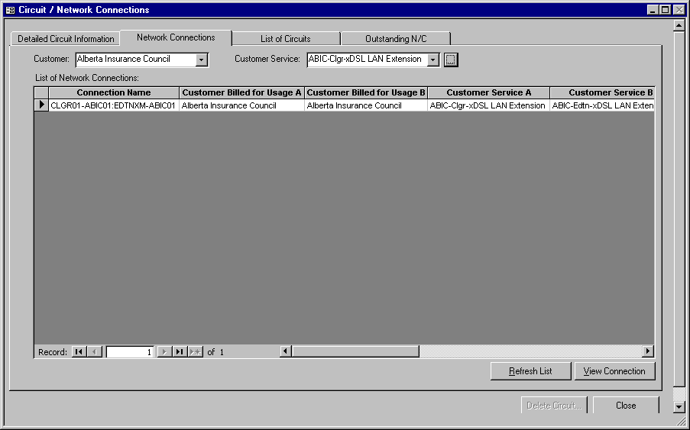

A Network Connection is a “logical” connection between two different service locations. This is a high level term used mainly by sales, customer care, and billing. For example, a customer may request a connection between its Calgary office to its Edmonton office. A network connection is “physically” built as one or more circuits. A network connection specifies who pays for the usage.

Customer
The customer combo box in the left-hand corner allows users to filter the list of network connections and the customer service combo box to information related to the customer. After selecting a customer the network connections displayed in the list and the customer service combo box will only have network connections and customer services related to the customer selected.

The button beside the customer combo box allows users to quick load the client vendor screen. If a customer has been selected the client vendor screen will display the information about that particular customer selected otherwise the first customer will be displayed.

Customer Service
The customer service combo box allows the user list the network connections, which belong to a particular customer service. By selecting a customer service the list will display only the network connections which belong to a specific customer service.

The button beside the customer service combo box loads the customer service screen. If a customer service has been selected the customer service screen will display the information about that particular customer service selected otherwise the first customer service will be displayed.

List of Network Connections
The list of network connections displays all the circuits which have a circuit type of PVC or CONNT (connection). Furthermore the list only display those connections which have both a Customer Service A and a Customer Service B, if either customer service is missing the connections will not be displayed. The list is for display purposes only. No modifications or additions are allowed. To modify a network connection, click the ‘View Connection’ button.

Refresh List
When a user adds a network connection to the database and switches to the network connection’s tab, the system automatically updates the list with the latest information. But if OSI or other SMA users are adding network connections, they may not appear on the system you are currently working on. By clicking on the ‘Refresh List’ button the list is updated with the latest information.

View Connection
To display the detailed information about a specific network connection simply select the network connection from the list and click the ‘View Connection’ button. This operation will switch to the Detailed Circuit Information section and displayed network connection information requested. Double clicking on a specific network connection will also perform the same operation.

List of Circuits

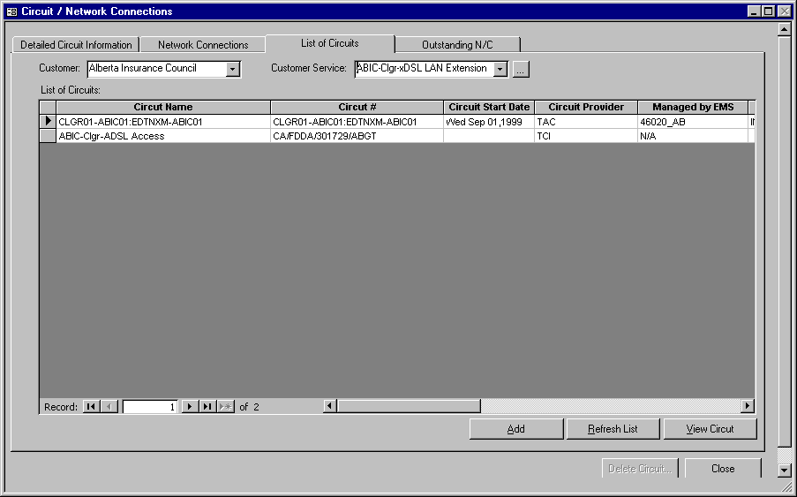
The List of Circuits section simply lists all the circuits that are currently in the database. The list can be filtered based on customer and customer service. By simply selecting a customer or customer service, the list will eliminated all records that do not match the customer or customer service selected.

Customer
The customer combo box in the left-hand corner allows users to filter the list of circuits and the customer service combo box to information related to the customer. After selecting a customer the circuits listed and the customer service combo box will only display those circuits and customer services related to the customer selected.

The button beside the customer combo box allows users to quick load the client vendor screen. If a customer has been selected the client vendor screen will display the information about that particular customer selected otherwise the first customer will be displayed.

Customer Service
The customer service combo box allows the user display the circuits, which belong to a particular customer service. By selecting a customer service the list will display only the circuits which belong to a specific customer service.

The button beside the customer service combo box loads the customer service screen. If a customer service has been selected the customer service screen will display the information about that particular customer service selected otherwise the first customer service will be displayed.

Add
By clicking the ‘Add’ button the application will simply switch to the Detailed Circuit Information section where you can enter a new circuit.

Refresh List
When a user adds a circuit to the database and switches to list of circuit’s tab, the system automatically updates the list with the latest information. But if OSI or other SMA users are adding circuit, they may not appear on the system you are currently working on. By clicking on the ‘Refresh List’ button the list is updated with the latest information.

View Circuit
To display the detailed information about a specific circuit, simply select the circuit from the list and click the ‘View Circuit’ button. Double clicking on a specific circuit in the list will also bring you to the detailed circuit information related to the network connections selected.

Outstanding Network Connections

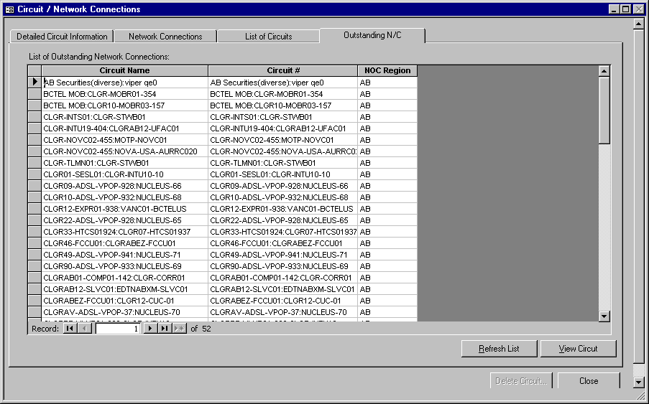
The information for a PVC circuit is usually entered automatically from OSI. The data that is entered in to the database form this automated process does not fill in the necessary customer service information required for a network connections. These records are listed in the Outstanding Network Connection. The user has the ability to modify, correct and fill in any customer service information that is missing. Once the customer service has been entered, the connection will no longer appear in the list.

Refresh List
When a network connection is added to the database by OSI, they may not immediately appear on the system you are currently working on. By clicking on the ‘Refresh List’ button the list is updated with the latest information.

View Circuit
To display the detailed information about a specific outstanding network connection, simply select the network connection from the list and click the ‘View Circuit’ button. Double clicking on a specific network connection in the list will also bring you to the detailed connection information.

Managed Objects – Design Engineers

Super Users:
MAS – Claude Aube,)
Internetworking –
ATM -

Managed Objects are classified as anything that is managed or monitored by TAC. They are defined for network and service management purposes and are the fundamental components that make up a customer service. The managed objects provide the necessary correlation between services and network resources.
.

Create a Managed Object

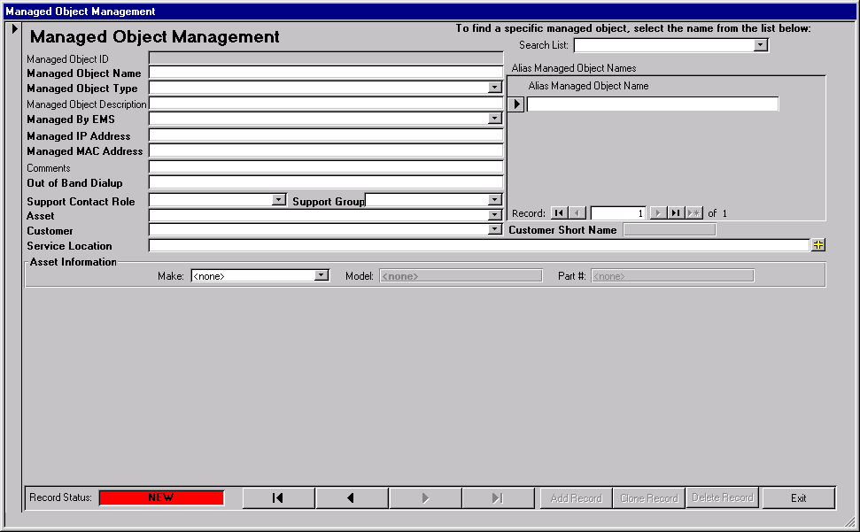

Managed Object ID – A unique, system generated number.

Managed Object Name – The Managed Object Name is usually described as a device name or a URL. A list of all managed object names is located in the drop down search list. It begins with the CLLI code of the Central Office the device is located in or works out of, followed by the customer short name, followed by a number to reveal how many devices there are for that customer. The URL’s must be copied exactly from their website.

Examples: EDTNAB02-BLCR01
VANCBC01-CADV01
www.tac.telus.com

Managed Object Type – Select from the dropdown selection list. The Managed Object Type controls the fielding in order to collect additional information i.e. for routers & edge devices.

Managed Object Description – A freeform field that is used to describe or differentiate the Managed Object when needed. This field should be used to specify the device type i.e. Cybersurf AS5300.

Alias Managed Object Name – If the Managed Object is referenced by another name outside of TAC, enter it here.

Managed by EMS – Element Management System. This is the name of the system or software that is used to managed the managed object.

Managed IP Address – The address OSC uses when sending SNMP requests and pings.

Managed MAC Address – The hardware address of the interface to which the Managed IP Address is assigned. It enables the Operations Service Centre to identify TAC’s router for management purposes. This prevents unauthorized access from the customers network into TAC’s Operations Service Centre. Only OSC bound traffic is allowed to pass through the secure connection. The MAC Address consists of 12 characters, both letters and numbers. They are grouped into two’s with divisions by a minus sign ( - ).

Example: 00-00-0C-FE-F8-30

Comments – This is a freeform field where the design engineer can enter any additional information about the managed object that is not captured elsewhere.

Out of Band Dial up - This is the phone number used by OSC to make contact with the managed object when the primary circuits are unavailable. These are considered a ‘Facility’ and are added to the database and attached to the Customer Service by the Implementation Managers. Only the phone numbers (IBL Facilities) that are attached to the Service Location will appear in this list. Select the number which applies to the Managed Object. If the correct number does not appear in the list, contact the Implementation Manager who is specified on the Customer Service Management window.

Support Contact Role - This is a finer breakdown of the Support Group.

Support Group - The group responsible for Service Assurance.

Asset - This lists the names of assets which are built in Asset Tracker.

Customer -

Service Location – All managed objects must be linked to a customer service. This list contains the addresses of all customer services in the database. If the Customer Service Location does not exist in the list, contact the Customer Service Management Super User (Lee Ettinger).

Asset Information- This information is displayed from Asset Tracker.

Create a Router Managed Object

When the Managed Object being created is a ROUTER the following window will be displayed. It contains the same generic managed object information as other types however a ROUTER has additional information that is useful for managing it.

The following window will display for a managed object that is a ROUTER.

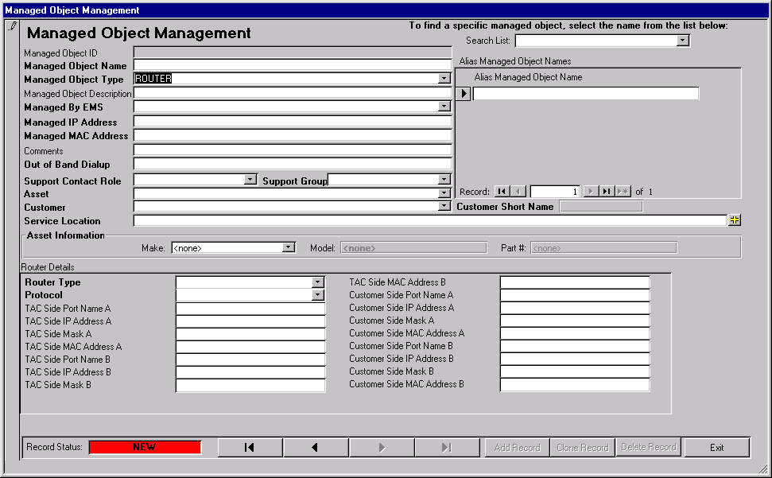

General Managed Object Information

Refer to section Create a Managed Object for field definitions.

Router Specific Information

Router Type: Router interface type.

Protocol: Routing protocol.

Port Addresses: The following fields allow you record and track the port addresses on a router.

Port Name:

IP Address:

Mask:

MAC Address:

Adding an Edge Device Managed Object

When the Managed Object being created is an EDGE the following window will be displayed. It contains the same generic managed object information as other types however an EDGE must also contain additional information that is useful for managing the object.

The following window will display for a managed object that is an EDGE device.

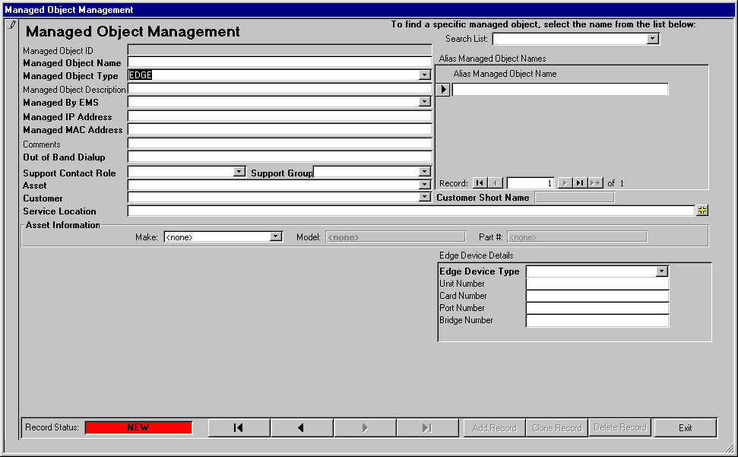

General Managed Object Information

Refer to section Create a Managed Object for field definitions.

EDGE Specific Information

This information is used to connect the Edge Device (Managed Object Type = EDGE or CAT5K) to the ATM Switch it is connected to. This connection information is very useful in tracking problems.

Edge Device Type:

ATM Switch Information: Fill this in if known. The information should be contained in the 46020.

Unit Number:

Card Number:

Port Number:

Bridge Number:

Changing Managed Objects

Changing the Location of the Managed Object - ??

Question - Should the Managed Object be attached to a Customer Service instead of a Service Location? Currently the user has the ability to attach a managed object to a completely different service than it gets correlated with. Why is a managed object being linked to a Customer Service here. Isn’t this really just correlating the managed object in a different place?

Moving the Managed Object to another Customer Service

? Open issue ? – To be covered in Apr 14 SMA User Group. Topic: How do we deal will a customer move.

Inactivating Managed Objects

A managed object can be inactivated by selected ‘TERM’ from the Status field dropdown list. The system will automatically set the Termination Date to the current date.

Question: When inactivating a Managed Object, Do we need to inactivate the Managed Object so that is no longer available for use anywhere or do we want to deactivate it from the customer service so it can be correlated to another service.

ATM PVC Management

Super User: Ken Nowakowski

Operations Service Centre (OSC) has accepted the responsibility to ensure that the logical customer service connections are maintained so that usage can be billed to customers.

When a new ATM PVC is set up in the ATM Network it will automatically be detected and inserted into the database with a Operational Status of ‘UNKNWN’.

IMPORTANT
In order to bill for usage on ATM PVCs, the following PVC Management information must be completed:

Billing Information,
Side A Information,
Side B Information.

FOR EACH DAY THAT THE ABOVE PVC MANAGEMENT DATA IS MISSING, THE CUSTOMER WILL NOT BE BILLED FOR THE USAGE COLLECTED ON THAT DAY.

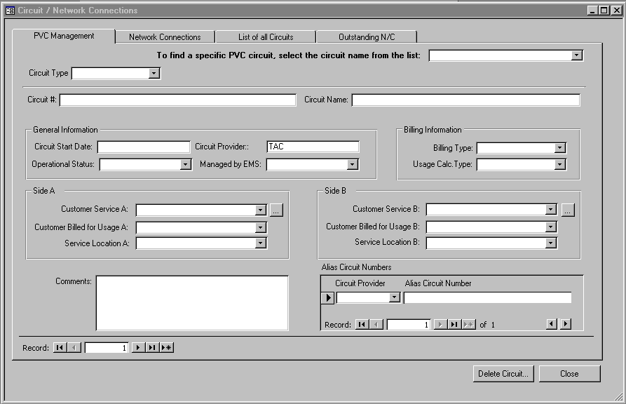

Circuit Type – Always ATM-PVC.

Circuit #/Circuit Name - The Circuit # is a unique number that references the PVC circuit. This field is populated with the circuit number from the ATM Network when the circuit is autodiscovered. The Circuit Name will default to be the same as the Circuit #, however it may be overwritten should you wish to have a more user-friendly description.

General Information:

Circuit Start Date – This is the date that the ATM PVC was autodiscovered. It is the date that the system can start collecting usage. The date will be inserted by the circuit discovery process, however it can be overwritten.

Circuit Provider – This is the organization that provisions the circuit. For ATM PVCs the circuit provider will always be TAC. The system will default the value to TAC, however the value can be overwritten.

Operational Status Code – There are 3 valid status codes:

UNKNWN – Unknown. This status is used for ATM PVC circuits only. A status of UNKNWN is set when the ATM PVC is autodiscovered by the Usage Collection Process. A circuit that is in ‘UNKNWN’ status will not generate revenue because the usage will not be passed to the billing system.

OPER – Operational. This status indicates that the PVC has been fully connected. It is collecting usage for a Customer Service.

TERM – Terminated. This status indicates that the PVC is no longer in use by a Customer Service.

Managed By EMS – This is the name of the Element Management Software that monitors the circuit.

Billing Information: Billing information is used by the daily usage rollup process. If this information is missing, the usage statistics will not be rolled into the table which is used by the billing process and therefore the customer will not be billed accurately for this circuit.

Billing Type: There are 11 options when choosing the correct billing type.

METRO – DO NOT USE this value. It was originally intended to indicate that the PVC logically connected two points within the same city. It has been replaced with LOCAL1, LOCAL2, LOCAL3.

LOCAL1 – Use when the PVC logically connects two points within the same MAJOR city within Alberta (i.e. Calgary, Edmonton)

LOCAL2 – Use when the PVC logically connects two points within the same MIDSIZE city within Alberta (i.e. Grande Prairie, Red Deer, Lethbridge)

LOCAL3 - Use when the PVC logically connects two points within the same SMALL city or town within Alberta (i.e. St. Albert, Sherwood Park).

IX – DO NOT USE this value. It was originally intended to indicate that the PVC logically connected two points in different cities (long distance). It has been replaced with REGIONAL1, REGIONAL2, REGIONAL3, NATIONAL1, NATIONAL2, NATIONAL3.

REGIONAL1 – Use when the PVC logically connects two points in two different MAJOR cities (i.e. connection between Calgary and Edmonton).

REGIONAL2 – Use when the PVC logically connects two points in two different cities where one of the cities is a MIDSIZE city and the other is either a MIDSIZE or MAJOR city. (i.e. Red Deer to Calgary, or Grande Prairie to Lethbridge).

REGIONAL3 – Use when the PVC logically connects two points in two different cities where one of the cities is a SMALL city/town and the other is either a SMALL, MIDSIZE or MAJOR city. (i.e. St. Albert to Calgary, or St. Albert to Lethbridge, or St. Albert to Sherwood Park).

NATIONAL1 – Use when the PVC logically connects two points within Canada where one or both points is outside of Alberta.

NATIONAL2 – Use when the PVC logically connects two points within North America where one or both points are outside of Canada.

NATIONAL3 – Use when the PVC logically connects two points in the World where one or both points are outside of North America.

Usage Calc Type: There are 3 options available, these are:

FREE – Choose this value when the PVC is not to be billed to the customer. For example, if you have a PVC which is to be used for stats collection only, set this indicator to ‘Free’.

INET – Choose this value when the PVC connects an internetworking service where both sides of the service are being billed for receipt usage.

LANIC – Choose this value when the service is a LAN Interconnect and only one side of the service is being billed to a customer and the other side connects to a TAC CO or POP.

Side A and Side B information is the logical connection of the PVC circuit. Side A and Side B are MANDATORY fields. They are required for the billing system and customer reporting to function properly.

Side A
Customer Service A - must be selected from the dropdown selection list.

Customer Billed for Side A – the system will default this to the customer who is using Customer Service A. Only change this value if it is known that a different customer should be billed for the service than the customer who is using the service.

Service Location A – will default to the service location specified on the Customer Service Management window.

Side B
Customer Service B - must be selected from the dropdown selection list.

Customer Billed for Side B - the system will default this to the customer who is using Customer Service B. Only change this value if it is known that a different customer should be billed for the service than the customer who is using the service.

Service Location B - will default to the service location specified on the Customer Service Management window.

Comments – A freeform field where information not captured elsewhere can be entered.

Alias Circuit Numbers: Only complete this information when a circuit used in a Customer Service is provided by a company other than TAC. This field holds information about the circuit that can be used to refer to it in the other company.

Circuit Provider – The name of the company providing the circuit.

Alias Circuit Number - The name the circuit is referred to by the provider company.

Making a Customer Service Operational - OSC

Super User: Ken Nowakowski

Find the Customer Service. The ‘Search List’ contains all Customer Service Names that are in the database. You can narrow the search list by typing in the Customer Service Name and the Search List will scroll to the first name starting with the letters typed.

If the Customer Service Name does not appear in the list, contact the Implementation Manager.

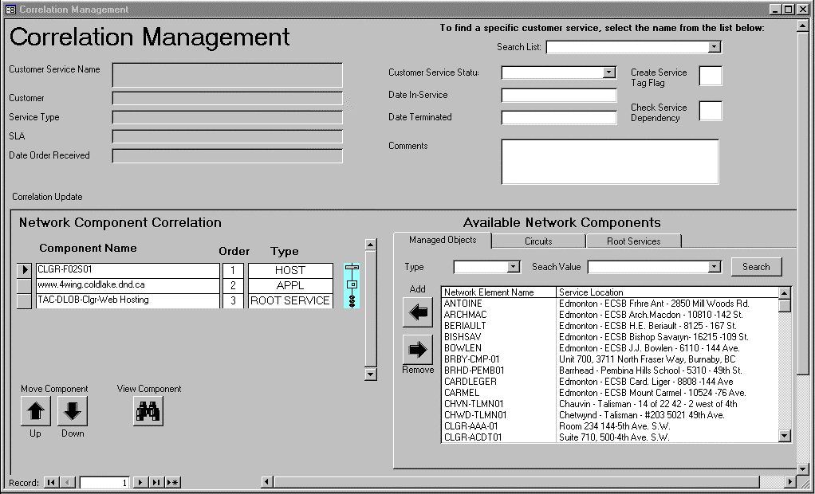

Attaching Network Elements to the Customer Service (Correlation Management)

To attach a network element to a customer service you want to select a managed object from the ‘Available Network Components’ and add it to the ‘Network Component Correlation’.

The Available Network Components are sub-divided into 3 sub-component types. These are:

Managed Objects Tab – this list contains all managed objects that are in the database and classified as being operational. To help in finding the managed object in the list, the list can be narrowed by selecting the managed object type from the ‘Type’ dropdown list or entering the first few characters of the Network Element Name (Managed Object Name).

Circuits Tab – this list contains all circuits that are in the database and classified as being operational. The circuit list contains both facilities (e.g. frame relay, fibre, ISDN, ADSL etc.) and ATM PVCs. To help in finding the circuit in the list, the list can be narrowed by selecting the circuit type from the ‘Type’ dropdown list or by entering the first few characters of the Circuit Name.

Root Services Tab – A root service is a service that correlates commonly used network elements that are used by a variety of other services. When a root service is attached or correlated to a Customer Service, the Customer Service automatically inherits the connection to the network elements that are attached to the Root Service.

To ADD a Network Component to the Customer Service (correlate the service), select the Managed Object/Circuit/Root Service from the ‘Available Network Components’ list by clicking it. Then click on the ‘ADD’ button. The selected network element should appear in the ‘Network Component Correlation’ list and disappear from the ‘Available Network Components’ list.

To REMOVE a Network Component from a Customer Service, select the component from the ‘Network Component Correlation’ list by clicking on it. Then click on the ‘Remove’ button. The selected component should disappear from the ‘Available Network Components’ list and appear back in the ‘Available Network Components’ list.

To VIEW a Network Component, select the Component Name from the ‘Network Component Correlation’ List. Then click the ‘View Component’ button. If the selected component is a managed object type, the Managed Object window will open to display the details. If the selected component is a facility circuit type, the Facilities window will open to display the details, if it is an ATM circuit the PVC Management window will open. If the selected component is a Root Service, the Customer Service Management window will display.

Activating/Terminating the Customer Service

There are 3 valid Status Codes for a customer service.
DESIGN – Implementation Managers are responsible for adding new customer services. New customer services have a status of design. A design status indicates that the customer service is not being monitored or supported by the Operations Service Centre (OSC) nor is the customer being invoiced for the service.
OPERATIONAL – The Operations Service Centre (OSC) is responsible for changing the status of a customer service to operational. An operational status indicates that the customer is free to use the service, OSC is fully monitoring and supporting the customer service and Customer Care is invoicing the customer for the service.
TERMINATED – The Operations Service Centre (OSC) is responsible for changing the status of a customer service to terminated. A terminated status indicates that the customer can no longer access and use the service, OSC is no longer monitoring and supporting the customer service and Customer Care is no longer billing the customer for that service.

To ACTIVATE a customer Service, set the Customer Service Status to ‘Operational’. The system will automatically set the Date In-Service to the current date. This date can be overwritten.
To DEACTIVATE a customer service, first remove all network elements that are correlated to the service (see Attaching Network Elements to the Customer Service (Correlation Management) process). Next set the Customer Service Status to ‘Terminated’. The system will automatically set the Date Terminated to the current date. This date can be overwritten.

IMPORTANT:
When a customer service is activated or deactivated, the Customer Service Manager and the Billing Specialist must be informed. The system will generate an E-mail note. Verify the recipients of the note and confirm that there is a Customer Service Manager and a Billing Specialist, if not add them to the recipient list. PRESS THE SEND BUTTON ON THE E-MAIL…DO NOT CANCEL THE E-MAIL MESSAGE.

Change Control Procedures –User Group

Role of the User Group

The User Group is made up of the Super Users identified in the SMA Process Ownership Model plus additional representatives from the IT department who represent systems that may be affected by the proposed changes.

The role of the Super User is to represent their peer group in the ownership of process, function and data for their area of responsibility. Super user responsibilities include:

- Identify and collect ideas for improvements from peer users.
- Analyze the impact of the improvement with regards to their function(s).
- Responsibly escalate improvement ideas and issues that overlap functional boundaries with the User Group for discussion.
- Participate in issue resolution to ensure the needs of the entire “Service Management” process are met.
- Update User Procedures document to reflect changes.
- Disseminate new and changed information to their peer group.

The role of the User Group Meeting is to serve as a forum where all issues regarding any process, data or system function can be shared with the other Super Users and IT representatives. The purpose is to fully understand the implications that a change or addition may have on other groups in the process. The primary responsibility of the User Group Meeting is to:

- Review and prioritize improvement ideas raised by Super Users since the previous meeting.
- Resolve issues that affect more than one functional area.
- Ensure system change requests are logged in the C3S program
- Review and approve change requests implemented in the latest release.

Change Process

Each Super User is responsible for issue resolution and maintenance of documentation within their functional areas.

Any change relating to DATA, PROCESS or SYSTEM should follow the following process:

- Conduct a preliminary analysis of the change request.
Ensure the change request is valid and that it cannot be solved with training. If the change request is valid, identify the groups that may be affected by the change. Get input from the identified Super Users regarding the potential impact of the change request.
- Log the change request as an item on the user group meeting agenda.
E-mail a note to the User Group Coordinator (currently Lee Ettinger). The note should contain a short description of the issue and an estimate of the amount of time it will take to fully discuss the issue in the meeting. Try to be realistic in your time estimate so that the meeting can be planned to cover all items.

AT THE USER GROUP MEETING

- Review and Discuss items on the agenda. The Super User responsible for logging the item should give background information on the change request for the rest of the user group.
- If it is determined by the user group that the change request is required and valuable continue with step 5, otherwise the issue should be closed and the Super User responsible for logging the item should communicate the resolution to the original requestor.
- If the change request results in enhancements or changes to the system, log the change request in the C3S application.
- If the change request results in process or data changes, each Super User is responsible to update the new process in the Procedures Document and also to communicate the new procedures to their peer user group.

Procedure Document Locations

ALL DOCUMENTS ARE STORED IN THE FOLLOWING DIRECTORY:

P:\TAC_Apps\Applications\Service Management\smcc\Procedures\ SMA Procedures

The CLLI code is a four character city code, followed by a two character province code, followed by a two character office code. i.e. CLGRAB02

